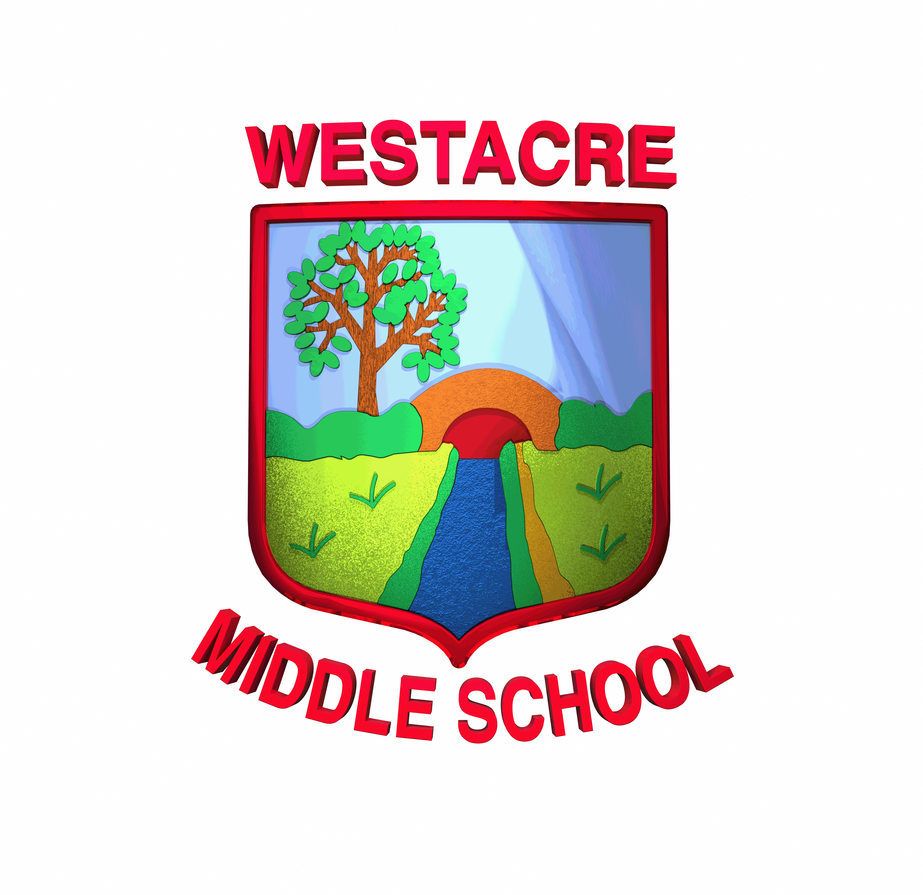
Year 5 Foundation Homework: Autumn Term

Your Challenge:
Pick any TWO activities from the choices below. You do not need to do them all! Be imaginative, explore your ideas and create something you are really proud to share.
DUE IN BY: WEDNESDAY 2ND DECEMBER 2026
(you can hand it in before this date)

SCIENCE | Space explorer  Choose an astronaut to investigate. What did they achieve? How did they inspire others? Include key facts and dates. Share your discoveries as a poster, speech or slideshow. | PE | Make a Maya game  Invent your own game inspired by the ancient Maya. Explain the rules and how to play.

GEOGRAPHY | Map maker  Choose a place in Central or South America. Draw a map and label natural features (like rivers and mountains) and human features (like cities), or map the journey of a famous explorer. | RELIGION & WORLD VIEWS | Maya beliefs  Find out about Maya religion and customs. Show what you learn through writing, a poster or a slideshow.

MUSIC | Maya sounds  Compose your own piece of music using an instrument that the Maya would have used. | COMPUTING | Build a Maya village  Use Minecraft or another computer program to create a Maya village. Take screenshots and explain your design in a slideshow.

HISTORY | Travel through time  Make a timeline of the ancient Maya civilisation. Include important events and discoveries, and show what came before and after (include images). | ENGLISH | Amazon animal expert  Choose an animal from the Amazon rainforest. Create an exciting fact-filled, non-chronological report (like an encyclopedia page)

MATHS | Maya number detective  Explore how the Maya used a base-20 number system. Show some examples and explain how their number system worked. | DT | Wonderful weaving  Discover why weaving mattered to the Maya, what materials they used and how a loom worked. Present your findings creatively.

FOOD TECHNOLOGY | Maya banquet  Research foods eaten by the Maya. Design a delicious-looking menu for a village banquet. | ART | Headdress designer  Design your own elaborate Maya-inspired headdress. Draw and colour it carefully, or build it using recycled materials.

MAKE IT BRILLIANT!
Take pride in every detail: use your best handwriting, thoughtful colours, careful drawings and clear explanations. You can work on paper, make something by hand or use a computer or tablet.
Need help or materials? Ask your teacher early. You can also ask to use the school library or for paper.
Digital homework: email your work to office@westacre.worcs.sch.uk. Include your name, class and “FAO your teacher”.

