Questions for Fiction Books

Inferring
- Can you predict what is going to happen next? Why did you make that prediction? Can you point to something in the book that helped you make that prediction? OR What do you already know that helped you make that prediction?
- Why did the character do that?
- What did the author mean by ….?
- What’s going to happen next?
- The character must be feeling *insert emotion*. Are there any clues that help us know that?

Summarising
- What is the problem to be solved in this story? Is there a solution?
- What has happened so far?
- In general, what is this story about?
- What do you wonder after reading so far?
- What is the most important point in this story or passage?

Synthesising
- Is there anything that you understand in a new way from reading this story?
- What idea’s (concepts or feelings) are the most interesting to you? Why?
- Does (a historical event or personal experience) make more sense after reading this?
- Does this book make you think of anything that has happened to you? If so, what?
- Does this story remind you of anything you have read?

Analysing
- What things would make everyone like this book?
- In what ways does the author make you feel as if you were there?
- What are some examples of rich, colourful, or great language that make this a good passage to read?
- What are the critical points in the plot? How does the story unfold?

Critiquing
- What is unbelievable about this text?
- Should other children read this? Why or why not?
- What important information is missing?
- Would people in your life act this way?
- What would have made this story more interesting to read?
- What are the words or phrases that you really liked or disliked?

Basic Recall/Explicit Questioning
- Who is the main character in the story?
- Who are the other characters in the story?
- What is your favourite part of the chapter or book?
- Describe your favourite character.
- Where do you think the story takes place? Why do you think that?
- When do you think the story takes place? Why do you think that?
- What is the problem in this story?
- How is the problem solved?
- Why do you think the author wrote this story? What did he/she want you to learn?

Questions for Non-Fiction Books
Most of the questions above relate to fictional stories. What happens if your child is reading a non-fiction book? These are questions for non-fiction books that you can ask:
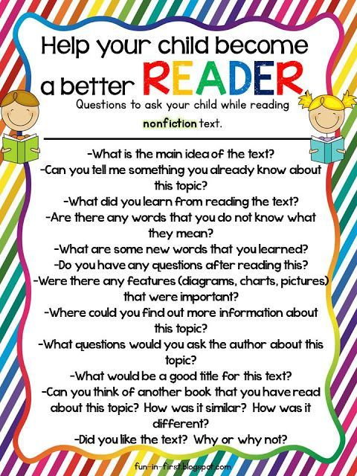Image Source: Fun-in-First

Questions to Engage the Reader
Before Reading:
- Why did you choose this book?
- What could this book be about?
- Have you read others books by this author?
- What do you see on the front cover?
- What is the title of the book?
While Reading:
- What is happening in the pictures?
- How is the character feeling?
- What could happen next?
- How would you describe the character?
- How would you feel if this happened to you?
After Reading:
- What was your favourite part? Why?
- What was the most interesting/exciting part of the book?
- Who was your favourite character? Why?
- Which word would you like to find out more about?
- If you were to rewrite the story, which part would you change?

(https://www.figur8.net/2018/03/21/reading-questions/)

