What the children said:
• I liked how the people inspired me to do some of their jobs when I grow up
• We learnt about other careers and how they fit it into normal life
• I loved hearing how fascinating other people's jobs are.
• It was very fun and I made new friends from different years like year 7.
• I loved the chance to see all the people that cut time of their work to come in and see us
• I liked Careers Day because it was interesting to find out about peoples' jobs and it inspired me to work hard to achieve my goals.
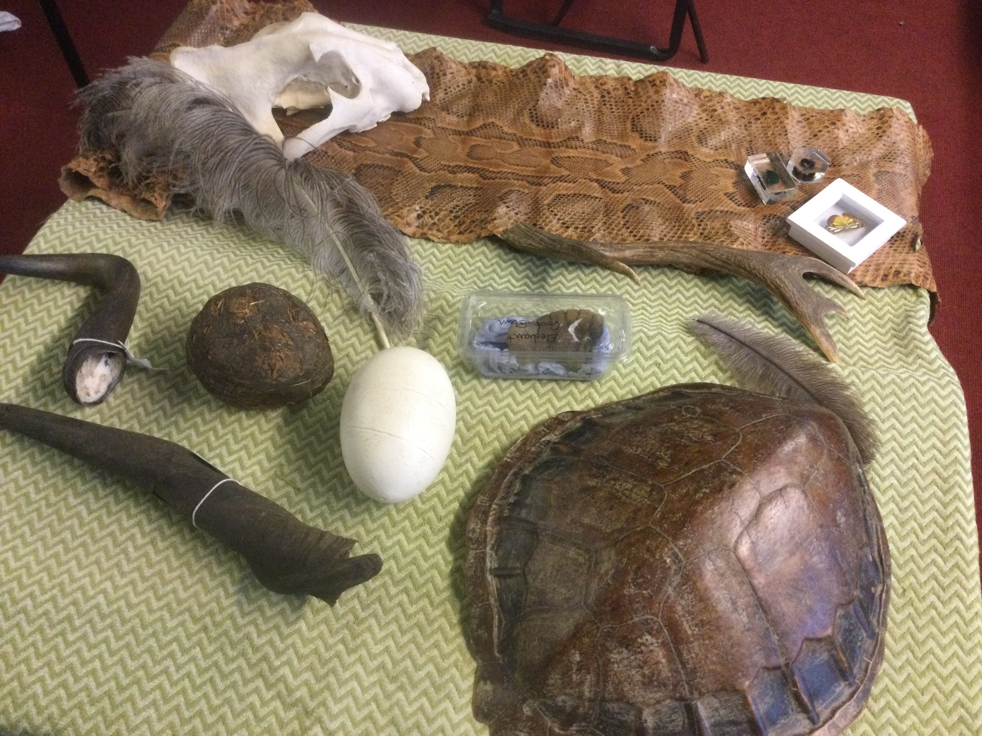

The Careers day focused on the following specific aims:
- To show women in high level roles of responsibility
- To show male and female workers breaking gender stereotypes
- To show a range of different sectors- construction, the services, retail creative industry etc.
- To increase understanding about career paths
- To enthuse them about a potential career and offer them a starting goal

The day involved splitting year 5, 6 and 7 pupils into groups of 20 pupils (with 23 different groups in total). Two year 7 pupils were selected prior to the day and were tasked with ensuring their groups were able to get to the correct ‘appointments’ around school at the correct time.

The day started with all pupils in the hall whilst the visiting speakers set up in the different rooms around school. The Careers Lead explained the purpose of the day to pupils and explained the logistics of how it would work, The assembly finished with a message from matt Richards, an Olympic gold medalist, that used to be a pupil at Westacre which seemed to inspire the children.

After the assembly, each group was taken to visit their first career. Each speaker was asked to talk about their career path, the good and bad parts of their job and what skills were needed to be succeesful in it. They then led an activity related to their careers. Ech group visited 6 different professions across the day. These included a chef, psychologist, pilot, nurse, chemical engineer, police officer, toy designer, architect, photographer, professional tennis umpire, zookeeper, electrician and many others.

450 pupils, 27 visiting speakers
Westacre Careers Day 2021
Worcestershire
Westacre Middle School
5.11.21

