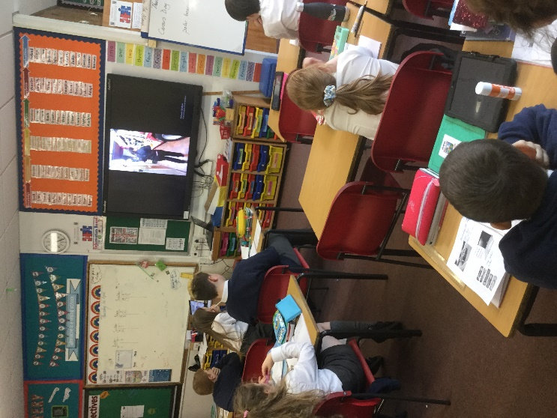
What the children said:
- I used to think that some jobs were for girls and others were for boys but now I don’t
- Now I know that some jobs are better paid that others and I don’t want to be NEET
- It’s not just about having a job; it’s about having a job that you enjoy
- I learned how hard you have to work to get a job
- Before I thought it was easy to live without a job- I’ve now changed my mind!
- I know what skills are strongly desired by employers

The Careers day focused on the following specific aims:
- To show women in high level roles of responsibility
- To show male and female workers breaking gender stereotypes
- To show a range of different sectors- construction, the services, retail creative industry etc.
- To increase understanding about career paths
- To enthuse them about a potential career and offer them a starting goal

The day was arranged into a series of different sessions with a range of different foci:
Year 5 aimed to widen their understanding of different job sectors through visual images
Year 6 looked at the wages paid to different professions and made moral judgements about this.
Year 7 looked at agri-tech for the Worcestershire STEM challenge competition.

Other activities within the morning involved pupils looking at their own personality traits through the Animal ME quiz, pupils creating mock interviews for each other to assess the first impressions they make and children also looked at issues surrounding gender stereotyping.

In the afternoon, all pupils accessed videos that had been created by different people form a range of jobs. These jobs included an MP, a penguin keeper, firefighters, train drivers and more. Many of these were sourced through existing staff working in the school and their contacts. The videos created will be stored and used for years to come.

450 pupils, 39 virtual speakers
Westacre Careers Day 2021
Worcestershire
Westacre Middle School
1.4.21

