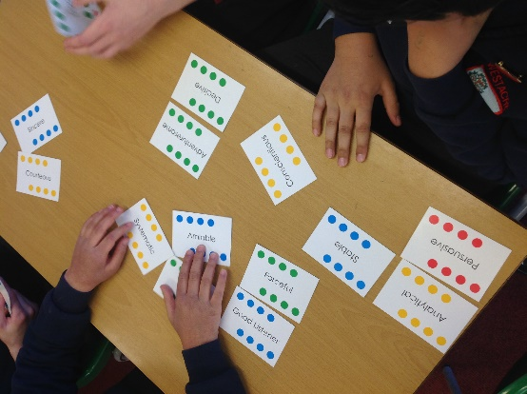
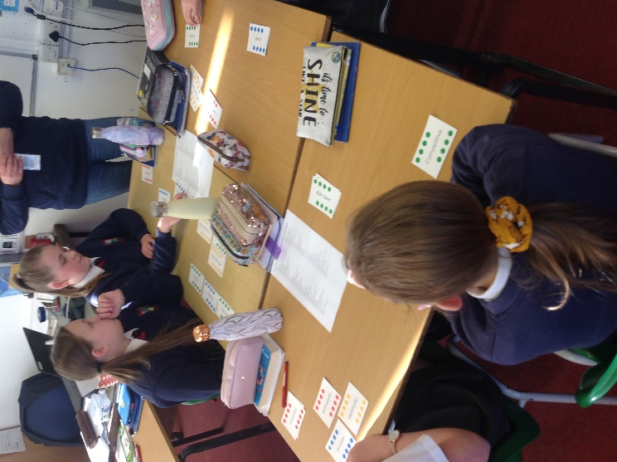

The Careers day focused on the following specific aims:
- Allow pupils to access expertise relating to Careers from visiting professionals
- Encourage children to consider their own personalities and what careers they would suit

The day was focused on the pupils exploring their own personality traits through a DISC analysis programme which looked at their core skills and values. To aid the pupils in analyzing their own personality strengths a series of activities across the day were organized.

This included, looking at interview technique, how to write a job application and offering the pupils opportunity to consider what careers their personal traits were suited to.

As part of the day Ian Clubley (the school’s Enterprise Advisor who is an Education Coach)) and Marie Jenkins (from Advance Your Wellbeing) visited and led a session with each of the year 7 classes. As part of this, pupils used a range of cards to assess their own and others’ personal strengths. This offered an opportunity for the children to be able to express the things they felt were their strengths and allowed them to post others’ self-esteem by verbalizing the strengths they felt their peers had. Discussing personal strengths has been a difficulty for many pupils. Following this, pupils unpicked the skills that they possessed for future employment and set targets they wished to achieve in order to prepare themselves for future employment.

The day, and in particular the session led by the visitors allowed the pupils to form a stronger understanding of their own key strengths and what they need to develop to attain their future employment goals. Several conversations since the day have been held which has demonstrated the impact it had on the children.
144 pupils
Year 7 Careers Day
Worcestershire
Westacre Middle School
25.2.20

