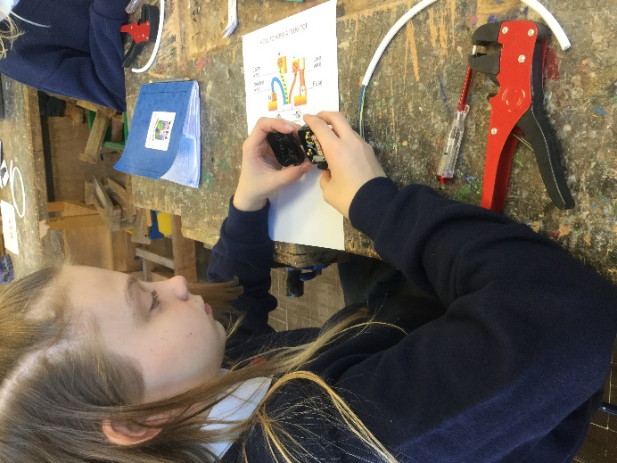
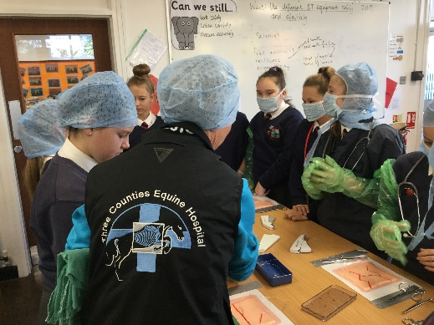

The Careers day focused on the following specific aims:
- To show women in high level roles of responsibility
- To show male and female workers breaking gender stereotypes
- To show a range of different sectors- construction, the services, retail creative industry etc.
- To increase understanding about career paths
- To enthuse them about a potential career and offer them a starting goal

The day was arranged into a series of 45 minute sessions
where the children moved around the school visiting different classrooms to learn about a range of employment opportunities.

Speakers were asked to allow the children to learn about their own individual career path, qualifications needed for the job, skill sets needed for the jobs, pros and cons of the job, any funny stories or surprises, why they chose the job. They were also asked to deliver a short activity for the pupils to put themselves in their shoes. This ranged from bandaging animals with the vet, writing wills with a solicitor, completing army drills with an army officer and creating headlines alongside the journalist.

Most of the speakers were sourced through families and friends of staff within school, alongside Westacre staff who had interesting employment prior to coming into education. Feedback was very positive form the children and the day will be repeated next year, if not before.

144 pupils and 20 speakers
Year 7 Careers Day
Worcestershire
Westacre Middle School
8.11.19

