Hello to Westacre Gardeners.
Hopefully you can get out into your garden or at least go on your daily exercise walk out and about with your family.
With the weather warming up, there is a lot going on in the air around us and on the ground beneath our feet. Why not take a closer look and go on a mini beast hunt?
Look under rocks, piles of wood/ sticks, look in long grass, on the bark of trees, on plant stems, in puddles, in fact everywhere.
Don’t touch the creature unless you have to; it might hurt them but it might also hurt you. If you want to take a closer look, use a spoon or leaf and put the bug into a bowl or plastic tub from recycling. See what it is and look at how many legs, wings, stripes, spots, eyes it has.
Can you identify it? If so, tick it off your list and remember, put it back carefully where you got it from.
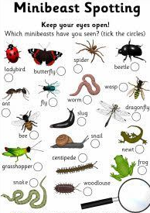

Bug | legs | wings | spots | colour | Tally
Ladybird | 6 | 2 | 7 | red | III

You could make a chart to keep count

.

Worms help to increase the amount of air and water that gets into the soil. They break down organic matter, like leaves and grass into things that plants can use. When they eat, they leave behind castings that are a very valuable type of fertiliser.
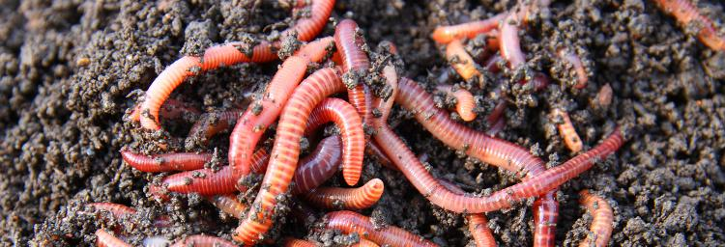
Believe it or not, wasps do more good than harm. They play a vital role in protecting gardens and farm crops by controlling pest populations. They capture and consume insects such as flies, caterpillars and beetle larvae. 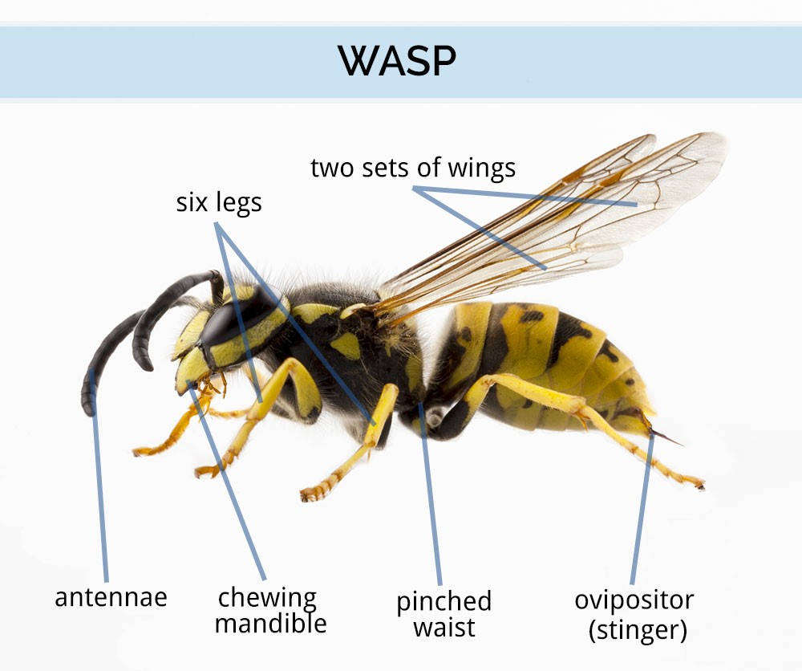 pillars and beetle larvae.
- Ants There are more than 12,000 species of ants all over the world.
- They can lift 20 times its own body weight. If a second- year child was as strong as an ant, she would be able to pick up a car!
- Ants don’t have ears. Ants "hear" by feeling vibrations in the ground through their feet.
- When ants fight, it is usually to the death!
- Queen ants have wings, which they shed when they start a new nest.
- Ants don’t have lungs. Oxygen enters through tiny holes all over the body and carbon dioxide leaves through the same holes.
Ants will eat almost anything, including other insects, 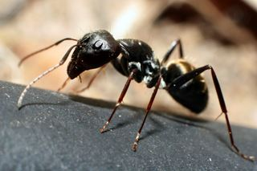 Are your ants Red or black?
. 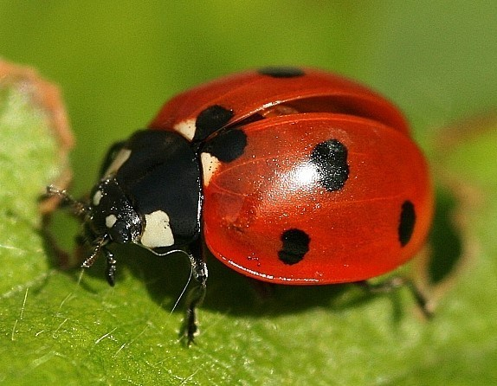
Ladybirds are generally considered useful insects and one of the greatest friends of the farmer and the gardener as many species feed on aphids (green fly) which are pests, eating new shoots and leaves. When they hatch, the ladybird larvae immediately start eating the aphids.
How many spots has your ladybird got?

Mini beast Facts

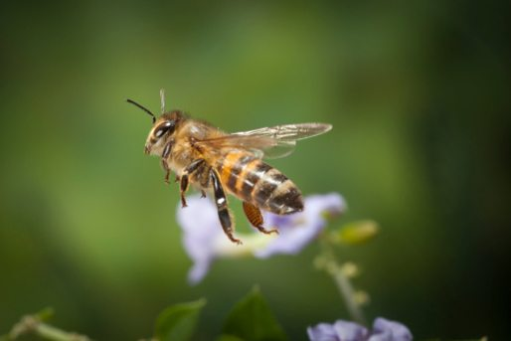
Frogs/ toads 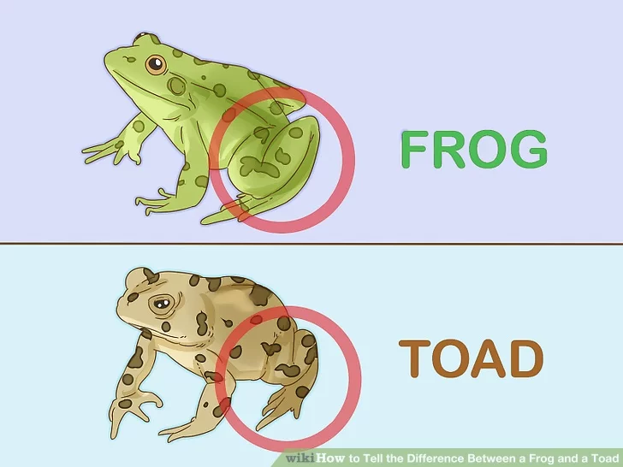
Frogs and toads will often eat any living thing that will fit into their mouths. This includes bugs, spiders, worms, slugs, larvae. Toads live in gardens, rough grassland, hedgerows and woodland, away from water whereas frogs live in almost any habitat where suitable breeding ponds are nearby.
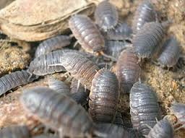
Woodlice feed on mildew and rotting plants, and can be large in numbers in compost heaps or under rocks in the garden. Common Woodlice feed on dead and decaying matter and are an important nutrient-recycler in the various habitats they live in.
How do they protect themselves?
Make your own fact file with drawings.
Bees are perfectly adapted to pollinate, helping plants grow, breed and produce food. They do so by transferring pollen between flowering plants and so keep the cycle of life turning. Honey bees are also brilliant boogiers! To share information about the best food sources, they perform their ‘waggle dance’. When the worker returns to the hive, it moves in a figure-of-eight and waggles its body to indicate the direction of the food source. The average worker bee lives for just five to six weeks. During this time, she’ll produce around a twelfth of a teaspoon of honey.
Land snails serve an important role in the ecosystem as they eat rotting vegetation like moist leaf litter, and also fungi and sometimes eat soil directly. Snails provide calcium and other nutrients vital to the formation of shells and embryos in birds.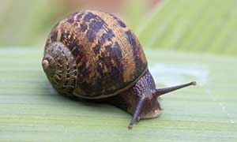
What else have you found?

